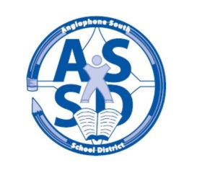
ANGLOPHONE SOUTH SCHOOL DISTRICT
2013-14 SCHOOL CALENDAR

2013
August 26 Administration Day for Staff
27-28 Council Days
29 Administration Day for Staff

September 2 Labour Day – No Classes
3 For all middle and high school students there will be a “transition day” with grades 6 and 9 only attending on Sept. 3.
4 All students grades 1 – 12 attend with the exception of Saint John Education Centre high schools where only grades 10 – 12 attend and grade 9’s do not attend

October 10-11 Professional Learning Days for Staff – No Classes
14 Thanksgiving Day – No Classes

November 11 Remembrance Day – No Classes
29 Parent Teacher Student Conferences K-12 – No Classes

December 20 Last Day of First Term – full day

2014
January 6 Professional Learning Day for Staff – No Classes
7 First Day for Students

February 17 Professional Learning Day for Staff – No Classes

March 3-7 March Break – No Classes
28 Grades K-12 Parent Teacher Student Conferences – No Classes

April 17 Professional Learning Day for Staff – No Classes
18 Good Friday – No Classes
21 Easter Monday – No Classes

May 2 Provincial Council Day – No Classes
16 Hampton Education Centre only - AEFNB & NBTA Meeting - No Classes
19 Victoria Day – No Classes

June 20 Last Day for Students

